EVENT ORGANIZER APP

Final Year Project Proposal

Session 2021-2024

**A 4th Year Student**

A project submitted in partial fulfillment of the

Abbottabad UST Degree

of

BSc. (Hons.) BS in Software Engineering



Department of Computer Science

Abbottabad University of Science & Technology

24 October 2023

**Project Registration**

|  |  |  |  |  |  |  |  |
| --- | --- | --- | --- | --- | --- | --- | --- |
| Project ID (for office use) | | |  | | | | |
| Type (Nature of project) | | | * **D**evelopment [ ] **R**esearch [ ] **R**&**D** | | | | |
| Area of specialization | | |  | | | | |
| **Project Group Members** | | | | | | | |
| Sr.# | Roll. # | Student Name | | CGPA | Email ID | Phone # | Signature |
| (i) | **10269** | Muhammad Mustafa | | 3.49 | Mustafaleo007@gmail.com | 03120718434 |  |
| (ii) | 10311 | Talha Ahmed | | 3.07 | Talhaahmed3761@gmail.com | 03115897566 |  |

# Plagiarism Free Certificate

This is to certify that, I am **Muhammad Mustafa** S/D/o **Hamayun Khan**, group leader of FYP under roll no **10269** at Computer Science Department, Abbottabad UST. I declare that my FYP proposal is checked by my supervisor and the similarity index is **10**% that is less than 20%, an acceptable limit by HEC. Report is attached herewith as Appendix A.

Date: ____________ Name of Group Leader: **Muhammad Mustafa**  Signature: _____________

Name of Supervisor: **Mir Jamal-UD-Din** Co-Supervisor (if any):

Designation: **Assistant Professor** Designation: **Assistant Professor**

Signature: _____________________ Signature: _____________________

**Approval of FYP Evaluation Panel**

Member 1: Name: _____________________

[ ] Accept [ ] Defer [ ] Reject Signature: _______________

Remarks: _____________________________________________________________________

Member 2: Name: _____________________

[ ] Accept [ ] Defer [ ] Reject Signature: _______________

Remarks: _____________________________________________________________________

FYP Coordinator: Name: _____________________

[ ] Accept [ ] Defer [ ] Reject Signature: _______________

Remarks: __________________________________________________________________

Table of content

1. Project Abstract

2. Introduction

3. Motivations and Scope

3.1 Motivation

3.2 Scope

4. Related Work

5. Requirements

5.1 Functional Requirements

5.2 Non Functional Requirements

6. Goals and Objectives

6.1 Goals

6.2 Objectives

7. Features of the project

8. Gantt Chart

9. Architectural Diagram

10. Tools and Technologies

11. References

**1 Project Abstract**

This project focuses on developing an event organizer app specifically for the Department of Computer Science at the university, aimed at streamlining the process of managing and attending academic events such as seminars, workshops, and other departmental events. Currently, organizing these events is often done manually, which can be time-consuming and inefficient, especially when handling multiple events and a large number of students. The app is designed to modernize this process, offering a user-friendly platform where admins can create and manage events effortlessly. They can input crucial event details such as the title, date, time, venue, and description, which will then be accessible to students. Students, on the other hand, can browse upcoming events, register online, and receive timely notifications regarding event updates or changes. Key features include user authentication, which ensures secure access using university emails, and an intuitive dashboard for admins to manage events efficiently. A simple calendar allows students to view scheduled events at a glance, while push notifications keep them informed about reminders or updates. The app also includes a search function, enabling students to find events by name or date quickly. The app’s simplicity ensures that both students and admins can navigate and use it without being overwhelmed by unnecessary features. While its initial focus is on the Department of Computer Science, the project has potential scalability to be used across other university faculties. Designed as a cross-platform application, it will be accessible through both mobile devices and web browsers, ensuring flexible access for all users. The app aims to make event management and participation a smooth and organized experience.

**2 Introduction**

University events, such as seminars, workshops, and other departmental events, are crucial for enhancing the academic and professional development of students. These events provide students with opportunities to learn, network, and engage with peers and experts in their field. However, the process of organizing and managing these events can often be time-consuming when done manually. Managing registrations, tracking attendees, updating event details, and sending notifications for changes or reminders can become overwhelming, particularly when managing multiple events and large numbers of participants. This manual process often leads to inefficiencies, delays, and errors that can affect both the organizers and the students. The proposed event organizer app aims to solve these challenges by providing a streamlined digital platform tailored to the Department of Computer Science at the university. The app will simplify the entire event management process by offering admins a user-friendly dashboard to create, edit, and manage events. Admins will be able to input essential event details such as the event title, date, time, venue, and description, allowing students to access all the necessary information in one place. The app will categorize events based on type such as workshops, seminars making it easier for students to browse and find relevant events. Students will also benefit from features that allow them to easily register for events online, track their registrations, and view upcoming events in a clear calendar format. The app’s notification system will send reminders for upcoming events and provide real-time updates if any changes occur, such as venue shifts or cancellations. Additionally, the search feature will enable students to quickly find events by name or date, ensuring they do not miss out on important opportunities. By focusing on basic event management features and maintaining a user-friendly interface, the app ensures that both students and administrators can efficiently coordinate departmental events. The goal is to reduce the workload for event organizers and provide a seamless, hassle-free experience for students, ultimately enhancing their ability to participate in academic and extracurricular activities. This app will bridge the gap between manual event handling and a more modern, digital approach, bringing simplicity and efficiency to the department's event coordination efforts.

**3 Motivations and Scope**

**3.1Motivation**  
The motivation behind this project is the need for a simple, and a way which provide ease to manage and keep track record of all the events within the Department of Computer Science. Currently, the departments are relying on manual methods for notifying students for each event, and keeping track of attendees. These methods often result in communication delays and require lot of man power to handle all the data of attendees.

**3.2 Scope:**

The scope of this project is to develop an event organizer app specifically for the Department of Computer Science. The app will include essential features to facilitate event management for both students and admins. Students will be able to register for events, view a calendar of upcoming activities, and receive notifications about event reminders and changes. Admins will have the capability to create, edit, and delete events with relevant details such as title, date, time, and venue. They will also manage registrations and track who has signed up, along with sending notifications to students regarding important updates. The app will be designed to work on Android devices and the web, ensuring accessibility for all users. The focus will be on keeping the app simple and user-friendly while meeting the core needs of organizing departmental events without adding unnecessary complexities. This project aims to enhance communication and efficiency in managing events within the department.

**Acceptance Criteria**

Users sign up using university emails.

Admins can create, edit, and delete events with all necessary details.

Students register for events, view schedules, and receive event notifications.

Calendar view and search functionality for easy navigation.

Notifications for upcoming events and changes.

**Limitations**

Limited to the Computer Science Department.

Covers only basic event categories like workshops and seminars.

Focuses on essential features for simplicity.

Prioritizes Android and web access, no iOS support initially.

**Deliverables**

Cross-platform app for event registration and management.

Admin dashboard for monitoring event participation.

Integrated calendar and notifications.

Searchable event database.

**Main Features**

Secure user authentication with university emails.

Admins manage event details and student registration.

Event calendar and notifications for updates.

Event search and admin dashboard for streamlined management.

**4 Related Work**

Several event management applications exist in the market, such as Eventbrite and Meetup, but these are geared towards a general audience and often include complex, unnecessary features. University-specific event apps, like those used for conferences, tend to be too large-scale and not tailored for departmental use. This project differentiates itself by focusing on the internal needs of the department, ensuring that the app remains lightweight, user-friendly, and specific to academic event management.

**5 Requirements**

**5.1 Functional Requirements:**

User authentication for students and admins using university emails.

Admins can create, edit, and delete events.

Students can register for events and track upcoming ones.

Notifications for event updates and reminders.

Search functionality to find events by name or date.

**5.2 Non-functional Requirements:**

The app should be intuitive and easy to navigate.

It should run smoothly on both Android and web platforms.

Notifications must be timely and reliable.

**6 Goals and Objectives**

**6.1 Goals**

The primary goal of this project is to create a user-friendly app that simplifies event management and eliminates the time consuming process of manually managing the data .

**6.2 Objectives**

Ensuring that students can easily register for events.

Providing admins with efficient tools to manage event details.

Sending timely reminders and notifications to users.

Implementing a calendar system that allows students to view upcoming events.

Building an intuitive search function for quick event lookup.

**7 Features of the Project**

**User Authentication**

Allows simple login/signup using university email for students and admins. Role-based access control distinguishes between student and admin functionalities.

**Event Management**

Admins can create, view, edit, and delete events with complete details like title, date, time, venue, and description. Events can be categorized into workshops, seminars, and departmental activities.

**Event Registration**

Students can easily register for events, and admins can track and manage RSVPs, including setting attendee limits. Students can also modify their registrations if necessary.

**Calendar and Schedule**

Displays all upcoming events in a simple calendar view for students. It provides the option to sync events with personal calendars and sends automatic event reminders to students.

**Notifications**

Sends push or email notifications for event reminders, updates on event changes like cancellations or reschedules, and other critical information.

**Search**

Allows students to search for events by name, date, or category, with filters to refine results based on event type or location.

**Admin Dashboard**

A user-friendly dashboard for admins to manage events, track RSVPs, and generate reports on event participation. Admins can also download attendee lists or export data as needed.

**8 Gantt Chart**

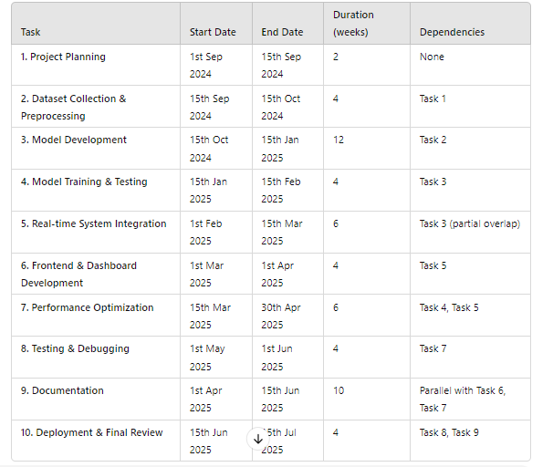

**9 Architectural Diagram**

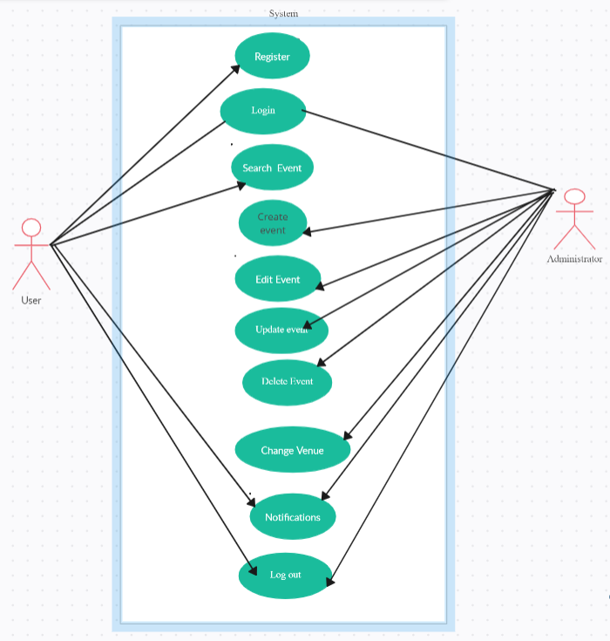

This diagram shows all the functionalities which both administrator and user can perform and they are limited to it only.

**10 Tools and Technologies**

**Frontend**

Flutter (for cross-platform mobile development)

**Backend**

Node.js or Django for handling server-side logic.

**Database**

Firebase or MySQL for storing user and event data.

**Push Notifications**

Firebase Cloud Messaging (FCM) for sending notifications.

**Version Control**

Git Hub for version control and collaboration.

**References**

References for this project will include academic papers on event management systems, as well as documentation for the technologies used such as Flutter, Firebase, and Node.js/Django. It will also include any relevant research on user interface design and cross-platform application development.

**…………………………… DO NOT WRITE BELOW THIS LINE ..…………………………**

|  |  |
| --- | --- |
| **FOR OFFICE USE ONLY** | |
| Approved | ❑ Yes  No |

**Checked & Approved/Not Approved By:**

Name: _______________________________________________________________________

Signature: ______________________________________________________________

Day Month Year

|  |  |  |  |  |  |  |  |  |  |  |
| --- | --- | --- | --- | --- | --- | --- | --- | --- | --- | --- |
| **DATE** |  |  | **–** |  |  | **–** |  |  |  |  |

Appendix A

*Include here the 1st page of Turnitin Report*